GUIDELINES FOR THE PREPARATION OF B.E. SEMINAR REPORTS
Since the seminar report reflect the quality and reputation of the student, faculty and institution the standards of the same should be high. So please observe the uniformity of the report you make following certain standard format.
- The seminar report should be brief, and the description of work carried out by others should be only to the minimum extent necessary. Verbatim reproduction of material available elsewhere should be strictly avoided. Where short excerpts from published work are desired to be included, they should be “within quotation marks” appropriately referenced.
- Proper attention is to be paid not only to the technical contents but also to the organization of report and clarity of expression. Due care should be taken to avoid spelling and typing errors. Consistency of format and spelling should be followed throughout the report.
- All the text matter except the title should be fully justified.
- Seminar report should be typed neatly on one side of the paper with 1.5 or double line spacing on an A4 size bond paper (210x297 mm). The margins should be: Left- 1.25”, Right- 1”, Top– 1” and Bottom– 1” (refer the sample template)
- Use BOLD CAPITALS ARIAL 18/20 for Title of the project depending on the length of the title. Use BOLD CAPITALS ARIAL 16 font size for chapter title, BOLD CAPITALS ARIAL 12 size for major text captions, Bold Arial 12 for sub-captions, and Arial 12 simple font for text matter.
- The chapters, sections and subsections may be numbered in the decimal format. For e.g.: Chapter 2, sections as 2.2, 2.5, etc., and subsections as 2.5.1, 2.5.2, 2.5.2.1 etc.
E.g.:
CHAPTER 1
INTRODUCTION
2.5 Morphometric Analysis: Morphometry is the measurement and ……............. …………… ……..……………………………………………………………

2.5.1 Methodology: In order to study the linear, areal and relief aspects of the Mulki………………………………………………………………………………………

2.5.2 Linear Aspects of Basin: The first step in drainage basin analysis is to delineate…….. ………………………………. …………………………….

- All the sections will have same cover page colour for B.E. seminar reports. Use only the prescribed logo printed cover page wrapper supplied from the college for the outer cover to have uniformity.
- Each student should prepare two spiral bound reports. One to be given to the department through their respective coordinators and other one is the student copy.
- Before taking the final print out, the approval of the concerned coordinators is mandatory and suggested corrections if any, must be incorporated.
- Seminar Report material should be divided clearly into PRELIMINARIES, MAIN TEXT and REFERENCE MATERIALS and should include the following in the given below sequence and format.
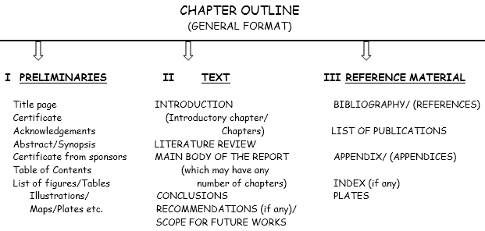

- PRELIMINARIES should be numbered in roman numerals (such as i, ii, iii, iv, ……), but the title pages need not be printed with page numbers even though they will be counted for numbering in sequential order.
- Chapters should contain Introduction, Main Body divided appropriately into chapters with sections and sub-sections, and Conclusions. They should be numbered and page numbered sequentially in Arabic numerals (such as 1, 2, 3, 4, …). The title pages of each chapter should not be printed with page numbers even though they will be counted for numbering in sequential order.
- The figures and tables must be numbered chapter wise with a suitable caption for the same. For e.g.: Fig. 2.1 Block diagram of a serial binary adder
Table 3.2 Primitive flow table, etc.
- All equation numbers should be right justified and important equations must be numbered in decimal form. For e.g.:
V/I = R ………. (3.4)
- Title page: Never use “seminar report on …………….” in the title of your seminar, since it is mentioned below as it is a seminar report submitted to the institute/university. Give only title of your seminar without any addition of seminar report on statement.

- Contents page should give a bird’s eye view of the entire report with its chapters, sections, sub-sections, etc., with page numbers for easy reference. A sample page of the same is given below (fig. 2).

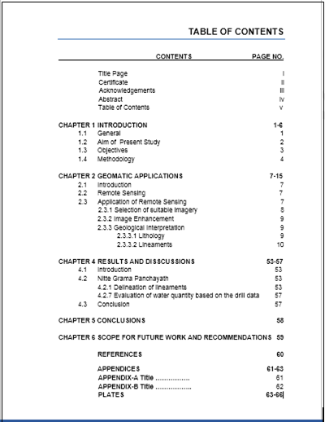
Fig. 2 Sample Style of Content page

- Reference Materials: This can be titled as REFERENCES placed immediately after the last chapter of the report without any chapter number but page numbers continued from the preceding chapter. It should be numbered serially in the order of their occurrence cited in the text and their numbers should be indicated within square brackets. Eg. ^{[3]}
- Listing of the References should be made in a logical arrangement in alphabetical and chronological order.
- The pattern of reference citing should be as follows: It should start with the left margin.
E.g.: For Text Books – Surname of the first author with a coma, followed by the first name of the first author either in abbreviation or full (woman author) followed in similar way for the other authors also, year of publication in bracket, Title of the Book in double inverted commas, Publisher Details, pages.
For Technical Papers – Surname of the first author with a coma, followed by the first name of the first author either in abbreviation or full (woman author) followed in similar way for the other authors also, year of publication in bracket, Title of the Paper in double inverted commas, Journal Name/Conference Proceedings Name, Volume Number and other details, page no./nos.

For Example:
Published Books:
Dobrin, S.M. (1991) “Introduction to Geophysical Prospecting”. McGraw- Hill, Singapore, pp.1-24,
568-622
Karanth, K.R. (1987) “Groundwater Assessment, Development and Management”. Tata McGraw
Hill, New Delhi, 610p.

Published Papers:
Radhakrishnan, K. and Lokesh, K.N. (2011) “Morphometric Evidences for Neotectonism in the
Mulki River Basin of Coastal Karnataka, India”. International Jour. of Earth Sciences and
Engg., v.4, no.4, pp. 643-650.

Edited Works:
Radhakrishnan, K. and Lokesh, K.N. (2010) “Remote Sensing and GIS Techniques for Delineation
and Mapping of Microwatersheds and Traditional Rainwater Harvesting Structures in Mulki River Basin for Sustainable Development”. In Eds: Srinivas Raju K. and Vasan, A., B.S. Publications, Hyderabad. pp. 292-302.

Proceedings of a Conference:
Radhakrishnan, K., Shenoy, K. N. and Lokesh, K.N. (2011) “Hydro geochemical studies of
groundwater along the coastal region of Mulki-Udupi, Karnataka state, India”. Proceedings of the International Engineering Symposium (IES2011-96), Kumamoto University, Japan, Ch: C7, sec.1, pp.1-8.

Unpublished Thesis:
Radhakrishnan, K. (2013) “Integrated Geohydrological Studies of Mulki River Basin, Karnataka,
India”. Unpublished doctoral thesis, National Institute of Technology Karnataka, India,
447p.

- A thorough review should be carried out in a systematic way reading several times, concentrating on one aspect at each time. A checklist can be used for this, and minimum four times should be reviewed for the following purposes: Logic, Expression, Punctuation and Layout.

Remember…, the seminar report is the hallmark and mirror of your intellect and hard work. So give utmost importance for its preparation.

